1. Do the following:
a. Describe the safety precautions you should take when handling and caring for a horse.
b. Describe the fire safety precautions you should take in a barn and around horses.

2. Name the 15 main parts of a horse.
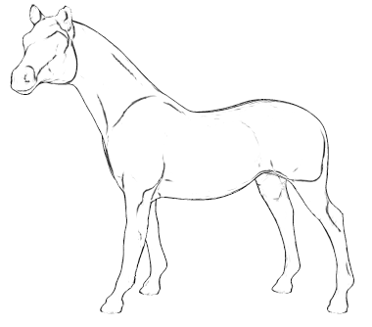
3. Name four breeds of horses. Explain the special features for which each breed is known.
1.
2.
3.
4.

4. Describe the symptoms of colic.
Name and describe four other horse health problems.
1.
2.
3.
4.
5. Explain what conformation is and why it is important.

Explain the difference between lameness and unsoundness.
6. Explain the importance of hoof care and why a horse might need to wear shoes.
Importance of hoof care
Why a horse might need to wear shoes
7. Demonstrate how to groom a horse, including picking hooves and caring for a horse after a ride.
How to groom a horse
Picking hooves
Caring for a horse after a ride
8. Explain how to determine what and how much to feed a horse and why the amount and kind of feed are changed according to the activity level and the breed of horse.
What to feed a horse:

How much to feed a horse:
Why the amount and kind of feed are changed according to the activity level and the breed of horse.
9. Do the following:
a. Name 10 parts of the saddle and bridle that you will use, and explain how to care for this equipment.
1.
2.
3.
4.
5.
6.
7.
8.
9.
10.

How to care for this equipment.
b. Show how to properly saddle and bridle a horse.
c. Demonstrate how to safely mount and dismount a horse.

10. Explain and demonstrate how to approach and lead a horse safely from a stall, corral, or field and how to tie the horse securely.
How to approach and lead a horse safely from a stall, corral, or field:

How to tie the horse securely:
11. On level ground, continuously do the following movements after safely mounting the horse. Do them correctly, at ease, and in harmony with the horse.
a. Walk the horse in a straight line for 60 feet.
b. Walk the horse in a half-circle of not more than 16 feet in radius.
c. Trot or jog the horse in a straight line for 60 feet.
d. Trot or jog the horse in a half-circle of not more than 30 feet in radius.
e. Halt straight.
f. Back up straight four paces.
g. Halt and dismount.

When working on merit badges, Scouts and Scouters should be aware of some vital information in the current edition of the Guide to Advancement (BSA publication 33088). Important excerpts from that publication can be downloaded from http://usscouts.org/advance/docs/GTA-Excerpts-meritbadges.pdf.
You can download a complete copy of the Guide to Advancement from http://www.scouting.org/filestore/pdf/33088.pdf.

