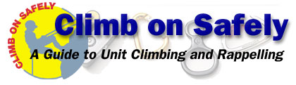
Climb On Safely is the Boy Scouts of America's recommended procedure for organizing BSA climbing/rappelling activities at a natural site or a specifically designed facility such as a climbing wall or tower.
Young people today seek greater challenges, and climbing and rappelling offer a worthy challenge. The satisfaction of safely climbing a rock face is hard to top. While introduction of the Climbing merit badge in spring 1997 spurred interest in these activities through the BSA, the proliferation of climbing gyms and facilities has also made climbing and rappelling readily available throughout the United States.
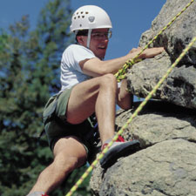
This increased interest has made the BSA more aware of the inherent risks of climbing and rappelling. More accidents occur during unit rappelling than during council-managed climbing or rappelling, and more accidents have occurred during rappelling than climbing. Many climbing/rappelling accidents could be avoided by having qualified instruction from a conscientious adult who has the attention and respect of the youth entrusted to his or her care. Supervision by a caring adult who fully understands and appreciates the responsibility he or she assumes helps assure safety when youth engage in or prepare for climbing or rappelling.
The adult supervisor's relationship with youth should reinforce the importance of following instructions. The adult leader in charge and the climbing instructor share this responsibility. The instructor is responsible for all procedures and for safely conducting the climbing/rappelling activity. The adult supervisor works cooperatively with the climbing instructor and is responsible for all matters outside of the climbing/rappelling activity.
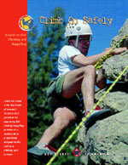
A capable instructor has experience in teaching climbing and rappelling to youth, acknowledges personal limitations, and exercises good judgment in a variety of circumstances. The person who just spent four days of free-solo climbing on a sheer rock face may have technical skills but may lack teaching ability or the ability to empathize with youth who may be apprehensive about climbing.
Examples of sources of qualified climbing and rappelling instructors include, but are not limited to, the following:
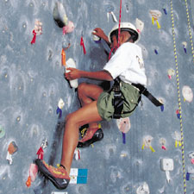
- National Outdoor Leadership School
- Wilderness Education Association
- American Mountain Guides Association
- The Mountaineers
- Recreational Equipment Inc.
- Eastern Mountain Sports
- University or college climbing/rappelling instructors or students
- Project COPE directors or instructors (until January 1, 2002)
- Project Adventure instructors
Leaders and instructors should also consult current literature on climbing and rappelling for additional guidance. Topping Out: A BSA Climbing/Rappelling Manual, No. 3207, is the most authoritative guide currently available from the Boy Scouts of America.
Mountaineering: The Freedom of the Hills, sixth edition, edited by Don Graydon and Kurt Hanson, is a recommended reference for specific questions not covered in BSA literature.
Units that elect to participate in lead climbing and snow and ice climbing should receive training from a nationally recognized organization that trains climbing and rappelling instructors. All council and district climbing must be top-roped.
Passport to High Adventure, No. 4310, published by the BSA, is an appropriate guidebook to safely get your unit to and from the climbing/rappelling site.
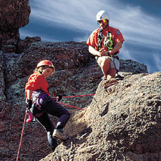
Cub Scouts and Webelos Scouts are encouraged to engage in climbing/rappelling in a controlled environment with close supervision by instructors who are knowledgeable about instructing this age group. Normally this means going to a climbing gym where the degree of difficulty is age-appropriate and the harnesses are size-appropriate for Cub Scouts. It is not recommended that Cub Scouts use climbing towers and walls in camp that have been designed for Boy Scout use.
Each of the following elements plays an important role in the overall Climb On Safely. Fun and safe climbing/rappelling activities require close compliance of Climb On Safely by the adult supervisor and instructor.

1. Qualified Supervision
All climbing and rappelling must be supervised by a mature, conscientious adult at least 21 years of age who understands the risks inherent to these activities. This person knowingly accepts responsibility for the well-being and safety of the youth in his or her care. This adult supervisor is trained in and committed to compliance with the eight points of the Boy Scouts of America's Climb On Safely procedure. One additional adult who is at least 18 years of age must also accompany the unit. Units with more than 10 youths in the same climbing/rappelling session must have an additional adult leader at least 18 years of age for each 10 additional youth participants. In other words, a group of 11 to 20 youths requires at least three adult leaders; a group of 21 to 30 youths would require four adult leaders, and so on.
The adult supervisor is responsible for ensuring that someone in the group is currently certified in American Red Cross Standard First Aid and CPR (a 6 1/2-hour course). In addition, the two-hour module "First Aid—When Help Is Delayed" is recommended. A course of equivalent length and content from another nationally recognized organization can be substituted. A higher level of certification such as emergency medical technician (EMT), licensed practical nurse (LPN), registered nurse (RN), and licensed health-care practitioner is also acceptable. The ARC's Emergency Response, a 431/2-hour course that includes CPR, is highly recommended.

2. Qualified Instructors
A qualified rock climbing instructor who is at least 21 years of age must supervise all BSA climbing/rappelling activities. The climbing instructor has successfully completed a minimum of 10 hours of instructor training for climbing/rappelling from a nationally or regionally recognized organization, a climbing school, a college-level climbing/rappelling course, or is a qualified BSA climbing instructor.
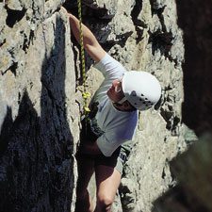
The BSA offers a section of National Camping School for climbing directors who in turn can train climbing instructors. (A Project COPE director or instructor fulfills this requirement until January 1, 2002.) Every instructor must have prior experiences in teaching climbing/rappelling to youth and must agree to adhere to Climb On Safely and the guidelines set in Topping Out.

NOTE: Any adult Scouter who successfully completes training in Climb On Safely is entitled to wear the temporary patch, No. 8631. A Climb On Safely Training Outline, No. 20-101, is available from your local council service center.

3. Physical Fitness
Require evidence of fitness for the climbing/rappelling activity with at least a current BSA Personal Health and Medical Record—Class 1, No. 34414. The adult supervisor should adapt all supervision, discipline, and precautions to anticipate any potential risks associated with individual health conditions. If a significant health condition is present, an examination by a licensed health-care practitioner should be required by the adult supervisor before permitting participation in climbing or rappelling. The adult supervisor should inform the climbing instructor about each participant's medical conditions.

4. Safe Area
All BSA climbing/rappelling activities must be conducted using an established or developed climbing/rappelling site or facility. A qualified climbing instructor should survey the site in advance of the activity to identify and evaluate possible hazards and to determine whether the site is suitable for the age, maturity, and skill level of the participants. The instructor should also verify that the site is sufficient to safely and comfortably accommodate the number of participants in the activity within the available time. An emergency evacuation route must be identified in advance.
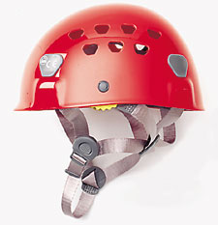

5. Equipment
The climbing instructor should verify that the proper equipment is available for the size and ability level of participants. Helmets, rope, and climbing hardware must be approved by the UIAA (Union Internationale des Associations d'Alpinisme) and/or CEN (European Community Norm). All equipment must be acquired new or furnished by the instructor.
Records must be kept on the use and stresses (the number of hard falls) on each item of equipment, which must be specifically designed for climbing and rappelling. Outside providers should be asked if they are aware of any stresses that have been put on their equipment. Any rope or webbing that has been subjected to more than three hard falls or that is four years old (whatever its use) must not be used. Refer to Topping Out concerning records that must be kept.

6. Planning
When planning, remember the following:
- Obtain written parental consent to participate in climbing/rappelling activities for each participant.
- In the event of severe weather or other problem, share the climbing/rappelling plan and an alternate with parents and the unit committee.
- Secure the necessary permits or written permission for using private or public lands.
- Enlist the help of a qualified climbing instructor.
- Be sure the instructor has a topographic map for the area being used and obtains a current weather report for the area before the group's departure.
It is suggested that at least one of the adult leaders has an electronic means of communication in case of an emergency.

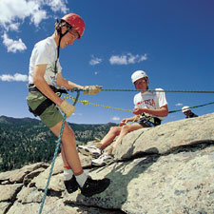
7. Environmental Conditions
The instructor assumes responsibility for monitoring potentially dangerous environmental conditions that may include loose, crumbly rock; poisonous plants; wildlife; and inclement weather. Use the buddy system to monitor concerns such as dehydration, hypothermia, and an unusually high degree of fear or apprehension. The adult supervisor is responsible for ensuring that the group leaves no trace of its presence at the site.

8. Discipline
Each participant knows, understands, and respects the rules and procedures for safely climbing and rappelling and has been oriented in Climb On Safely. All BSA members should respect and follow all instructions and rules of the climbing instructor. The applicable rules should be presented and learned prior to the outing and should be reviewed for all participants before climbing or rappelling begins. When participants know the reasons for rules and procedures, they are more likely to follow them. The climbing instructor must be strict and fair, showing no favoritism.

Although the BSA has an excellent safety record, there is inherent risk in climbing and rappelling. With proper management, that risk can be minimized. When a climber is 6 feet or more above the ground, nothing should be left to chance.
Leaders should be aware that Climb On Safely is an orientation only and does not constitute training on how to climb or rappel.

The Boy Scouts of America |  | http://www.bsa.scouting.org

